REVERVIEW B2B ASSESSMENT DOCUMENTATION

* **Getting start**
* Go to the htdocs folder where you have installed .Open the cmd. Run this command “ git clone https://github.com/deshdilshan/riverviewcs.git “
* Go to the project file which is reverviewcsassesments.
* Config the .env file. [put the username, password and database name of the database]
* Run “php artisan migrate”
* Go to this [URL](https://chrome.google.com/webstore/detail/postman/fhbjgbiflinjbdggehcddcbncdddomop?hl=en) and install the postman chrome app in your chrome browser.
* **API Documentation**

* **Create new author**

Copy this <http://localhost/riverviewcsassesments/public/api/author> paste in the postman and this is post type request. And create the headers like this.

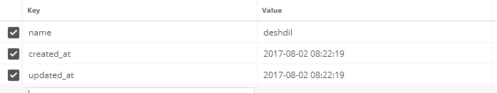

If it is success will see this like output.

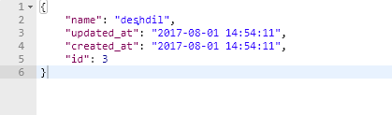

* **Create new article**

Copy this [http://localhost/riverviewcsassesments/public/api/](http://localhost/riverviewcsassesments/public/api/author)articles paste in the postman and this is post type request. And create the headers like this.

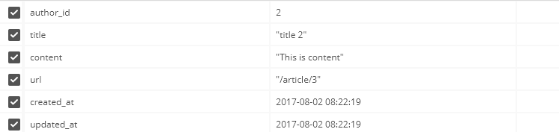

If it is success will see this like output.

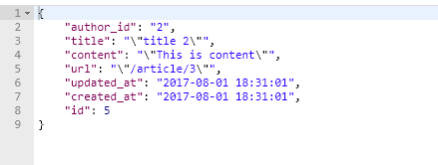

* **READ route for ALL articles​.**

Copy this [http://localhost/riverviewcsassesments/public/api/](http://localhost/riverviewcsassesments/public/api/author)articles paste in the postman and this is get type request. It’s Output like this.

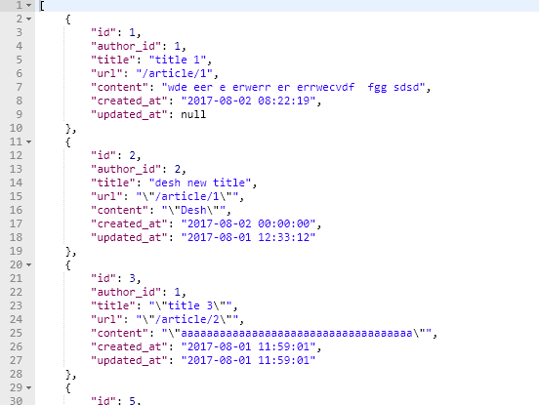

* **READ route for One articles​.**

Copy this [http://localhost/riverviewcsassesments/public/api/](http://localhost/riverviewcsassesments/public/api/author)articles/1 paste in the postman and this is get type request. It’s Output like this.

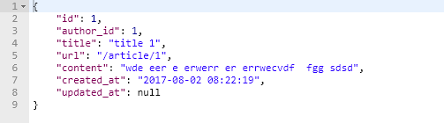

* **UPDATE route for an article**

Copy this http://localhost/riverviewcsassesments/public/api/articles/2 paste in the postman and this is put type request. And create the headers like this.

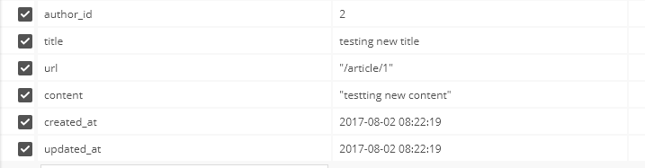

If it is success will see this like output.

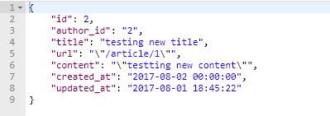

* **Delete route for an article**

Copy this [http://localhost/riverviewcsassesments/public/api/](http://localhost/riverviewcsassesments/public/api/author)articles/4 paste in the postman and this is get type request. This is HTTP code 204. There is no any return.

* Backup Database

Add this cron in your server

* * * * * php /path/to/artisan schedule:run 1>> /dev/null 2>&1

Or if you need to see that manually run this command

php artisan db:backup

The backup file will store in the public/opt/backup/database folder.